

A PROJECT REPORT

ON



FORTUNE-MAKER

SUBMITTED BY

● Santosh Kumar Morya (201500620)

● Vaibhav Varshney (201500766)

● Himanshu Kushwaha (201500296)

● Mradul Varshney (201500414)

● Garima Gautam (201500242)

Department of Computer Engineering & Applications

**Institute of Engineering & Technology GLA University**

**Mathura-281406**

**Declaration**

We hereby declare that the work in the project report entitled "**FORTUNE MAKER**" GLA University ,Mathura for the award of degree of "B.Tech" is an authentic record of my work carried out during the Fifth semester Third year, 2022 under the supervision of Mr. Rahul Pradhan. The matter embodied in this project report has not been submitted elsewhere by anybody for the award of any other degree/diploma.

|  |  |  |
| --- | --- | --- |
| S.NO | NAME | UNIVERSITY ROLLNO |
| 1 | Santosh Kumar Morya | 201500620 |
| 2 | Mradul Varshney | 201500414 |
| 3 | Vaibhav Varshney | 201500766 |
| 4 | Himanshu Kushwaha | 201500296 |
| 5 | Garima Gautam | 201500706 |

**CERTIFICATE**

This is to certify that the project entitled "FU" has been developed by **B.Tech** students of **GLA University,Mathura** towards partial fulfillment of the requirements for the award of the degree of Bachelor of Computer Science is a genuine record of the work carried out by Him/her under My Supervision and Guidance and the project report is the original work of student. She/he has worked on the project Airline **FORTUNE MAKER**. She/he has used CSS, HTML, JAVASCRIPT for the project. His/her work is satisfactory. I wish him/her all the best for his bright future***.***

**Date:19/10/2022** **Signature of Guide**

Place:Mathura Mr. Amir Khan

**Acknowledgement**

The beatitude, bliss & euphoria that accompany the successful completion of any task would be incomplete without the expression of the appreciation of simple virtues to the people who made it possible. So ,with reverence, veneration and honors. We acknowledge all those whose guidance and encouragement has made successful in winding up this.

We owe a huge debt of thanks too many people without whom none of this would have been possible. We are thankful to Mr. Amir Khan (Project Guide) for valuable suggestions and enthusiastic interest during the entire session.

Finally, we are very much grateful to the Institute and all the Faculty members, without their personal attention and time to time help and care, it would not have been possible for us to complete this report.

We perceive as this opportunity as a big milestone in my career development. I will strive to use gained skills and knowledge in the best possible way, and I will continue to work on their improvement, in order to attain desired career objectives. Hope to continue cooperation with all of you in the future.

Index

TITLE Page No.

1. INTRODUCTION 6
   1. **Project Overview**  6
   2. **Project Description** 6
2. TECHNOLOGIES USED 7
   1. **HTML**  7
   2. **CSS** 9
   3. **JAVASCRIPT** 10
   4. **BOOTSTRAP** 12
   5. **NODE JS**
   6. **EXPRESS JS 14**
3. SOURCE CODE 15
4. PREVIEWS 36
5. CONCLUSION 44
6. REFRENCES 45

**INTRODUCTION**

**1.1. Project Overview**

**“FORTUNE MAKER”** as the name suggested this website provide the opportunity to the user by provide them resources about the courses that are required in Engineering. This website contains all the information about the event .

**1.2. Project Description**

**“FORTUNE MAKER”** is the website which provide you all the information about opportunity that surrounds you. It gives you information about the events that are organized in your locality.it provide you opportunity to develop your personality in whole new way.

This website introduce you to whole new world. It provides new experiences that helps you to see the life in different perspective. It helps you to explore the new options other than the your academics. This website provides information like date , venue , prize, etc about the event .Even you can book your tickets from this website.

This website is of advantage for the person who want do publicity of the their event. This website is the common platform for all type of events such as cultural event ,sport events , seminar, workshops, and many more opportunity.

**Technologies Used**

**HTML:**

HTML is an acronym which stands for **Hyper Text Markup Language** which is used for creating web pages and web applications. Let's see what is meant by Hypertext Markup Language, and Web page.

**Hyper Text:** HyperText simply means "Text within Text." A text has a link within it, is a hypertext. Whenever you click on a link which brings you to a new webpage, you have clicked on a hypertext. HyperText is a way to link two or more web pages (HTML documents) with each other.

**Markup language:** A markup language is a computer language that is used to apply layout and formatting conventions to a text document. Markup language makes text more interactive and dynamic. It can turn text into images, tables, links, etc.

**Web Page:** A web page is a document which is commonly written in HTML and translated by a web browser. A web page can be identified by entering an URL. A Web page can be of the static or dynamic type. **With the help of HTML only, we can create static web pages**.

## **Description of HTML Example**

**<!DOCTYPE>:** It defines the document type or it instruct the browser about the version of HTML.

**<html >** :This tag informs the browser that it is an HTML document. Text between html tag describes the web document. It is a container for all other elements of HTML except <!DOCTYPE>

**<head>:** It should be the first element inside the <html> element, which contains the metadata(information about the document). It must be closed before the body tag opens.

**<title>:** As its name suggested, it is used to add title of that HTML page which appears at the top of the browser window. It must be placed inside the head tag and should close immediately. (Optional)

**<body>**: Text between body tag describes the body content of the page that is visible to the end user. This tag contains the main content of the HTML document.

**<h1>** : Text between <h1> tag describes the first level heading of the webpage.

## **Brief History of HTML**

In the late 1980's , a physicist, Tim Berners-Lee who was a contractor at CERN, proposed a system for CERN researchers. In 1989, he wrote a memo proposing an internet based hypertext system.

**Tim Berners-Lee** is known as the father of HTML. The first available description of HTML was a document called "HTML Tags" proposed by Tim in late 1991. The latest version of HTML is HTML5, which we will learn later in this tutorial.

## **HTML Versions**

Since the time HTML was invented there are lots of HTML versions in market, the brief introduction about the HTML version is given below:

**HTML 1.0:** The first version of HTML was 1.0, which was the barebones version of HTML language, and it was released in1991.

**HTML 2.0:** This was the next version which was released in 1995, and it was standard language version for website design. HTML 2.0 was able to support extra features such as form-based file upload, form elements such as text box, option button, etc.

**HTML 3.2:** HTML 3.2 version was published by W3C in early 1997. This version was capable of creating tables and providing support for extra options for form elements. It can also support a web page with complex mathematical equations. It became an official standard for any browser till January 1997. Today it is practically supported by most of the browsers.

**HTML 4.01:** HTML 4.01 version was released on December 1999, and it is a very stable version of HTML language. This version is the current official standard, and it provides added support for stylesheets (CSS) and scripting ability for various multimedia elements.

**HTML5 :** HTML5 is the newest version of HyperText Markup language. The first draft of this version was announced in January 2008. There are two major organizations one is W3C (World Wide Web Consortium), and another one is WHATWG( Web Hypertext Application Technology Working Group) which are involved in the development of HTML 5 version, and still, it is under development.

## **Features of HTML**

1) It is a very **easy and simple language**. It can be easily understood and modified.

2) It is very easy to make an **effective presentation** with HTML because it has a lot of formatting tags.

3) It is a **markup language**, so it provides a flexible way to design web pages along with the text.

4) It facilitates programmers to add a **link** on the web pages (by html anchor tag), so it enhances the interest of browsing of the user.

5) It is **platform-independent** because it can be displayed on any platform like Windows, Linux, and Macintosh, etc.

6) It facilitates the programmer to add **Graphics, Videos, and Sound** to the web pages which makes it more attractive and interactive.

7) HTML is a case-insensitive language, which means we can use tags either in lower-case or upper-case

**CSS:**

CSS stands for Cascading Style Sheets. It is a style sheet language which is used to describe the look and formatting of a document written in markup language. It provides an additional feature to HTML. It is generally used with HTML to change the style of web pages and user interfaces. It can also be used with any kind of XML documents including plain XML, SVG and XUL.

CSS is used along with HTML and JavaScript in most websites to create user interfaces for web applications and user interfaces for many mobile applications.

## **What does CSS do**

* You can add new looks to your old HTML documents.
* You can completely change the look of your website with only a few changes in CSS code.

## **Why use CSS**

These are the three major benefits of CSS:

## **1) Solves a big problem**

Before CSS, tags like font, color, background style, element alignments, border and size had to be repeated on every web page. This was a very long process. For example: If you are developing a large website where fonts and color information are added on every single page, it will be become a long and expensive process. CSS was created to solve this problem. It was a W3C recommendation.

## **2) Saves a lot of time**

CSS style definitions are saved in external CSS files so it is possible to change the entire website by changing just one file.

## **3) Provide more attributes**

CSS provides more detailed attributes than plain HTML to define the look and feel of the website.

**JAVASCRIPT:**

## **What is JavaScript**

JavaScript (js) is a light-weight object-oriented programming language which is used by several websites for scripting the webpages. It is an interpreted, full-fledged programming language that enables dynamic interactivity on websites when applied to an HTML document. It was introduced in the year 1995 for adding programs to the webpages in the Netscape Navigator browser. Since then, it has been adopted by all other graphical web browsers. With JavaScript, users can build modern web applications to interact directly without reloading the page every time. The traditional website uses js to provide several forms of interactivity and simplicity.

Although, JavaScript has no connectivity with Java programming language. The name was suggested and provided in the times when Java was gaining popularity in the market. In addition to web browsers, databases such as CouchDB and MongoDB uses JavaScript as their scripting and query language.

## **Features of JavaScript**

There are following features of JavaScript:

1. All popular web browsers support JavaScript as they provide built-in execution environments.
2. JavaScript follows the syntax and structure of the C programming language. Thus, it is a structured programming language.
3. JavaScript is a weakly typed language, where certain types are implicitly cast (depending on the operation).
4. JavaScript is an object-oriented programming language that uses prototypes rather than using classes for inheritance.
5. It is a light-weighted and interpreted language.
6. It is a case-sensitive language.
7. JavaScript is supportable in several operating systems including, Windows, macOS, etc.
8. It provides good control to the users over the web browsers.

## **History of JavaScript**

In 1993, **Mosaic**, the first popular web browser, came into existence. In the **year 1994**, **Netscape** was founded by **Marc Andreessen**. He realized that the web needed to become more dynamic. Thus, a 'glue language' was believed to be provided to HTML to make web designing easy for designers and part-time programmers. Consequently, in 1995, the company recruited **Brendan Eich** intending to implement and embed Scheme programming language to the browser. But, before Brendan could start, the company merged with **Sun Microsystems** for adding Java into its Navigator so that it could compete with Microsoft over the web technologies and platforms. Now, two languages were there: Java and the scripting language. Further, Netscape decided to give a similar name to the scripting language as Java's. It led to 'Javascript'. Finally, in May 1995, Marc Andreessen coined the first code of Javascript named '**Mocha**'. Later, the marketing team replaced the name with '**LiveScript**'. But, due to trademark reasons and certain other reasons, in December 1995, the language was finally renamed to 'JavaScript'. From then, JavaScript came into existence.

## **Application of JavaScript**

JavaScript is used to create interactive websites. It is mainly used for:

* Client-side validation,
* Dynamic drop-down menus,
* Displaying date and time,
* Displaying pop-up windows and dialog boxes (like an alert dialog box, confirm dialog box and prompt dialog box),
* Displaying clocks etc.

# **What is Bootstrap**

* Bootstrap is the most popular HTML, CSS and JavaScript framework for developing a responsive and mobile friendly website.
* It is absolutely free to download and use.
* It is a front-end framework used for easier and faster web development.
* It includes HTML and CSS based design templates for typography, forms, buttons, tables, navigation, modals, image carousels and many others.
* It can also use JavaScript plug-ins.
* It facilitates you to create responsive designs.

### **History of Bootstrap**

Bootstrap was developed by Mark Otto and Jacob Thornton at Twitter.It was released as an open source product in August 2011 on GitHub.

In June 2014 Bootstrap was the No.1 project on GitHub.

### **Why use Bootstrap**

Following are the main advantage of Bootstrap:

* It is very easy to use. Anybody having basic knowledge of HTML and CSS can use Bootstrap.
* It facilitates users to develop a responsive website.
* It is compatible on most of browsers like Chrome, Firefox, Internet Explorer, Safari and Opera etc.

### **What is a responsive website**

A website is called responsive website which can automatically adjust itself to look good on all devices, from smart phones to desktops etc.

### **What Bootstrap package contains**

**Scaffolding:** Bootstrap provides a basic structure with Grid System, link styles, and background.

**CSS:** Bootstrap comes with the feature of global CSS settings, fundamental HTML elements style and an advanced grid system.

**Components:** Bootstrap contains a lot of reusable components built to provide iconography, dropdowns, navigation, alerts, pop-overs, and much more.

**JavaScript Plugins:** Bootstrap also contains a lot of custom jQuery plugins. You can easily include them all, or one by one.

**Customize:** Bootstrap components are customizable and you can customize Bootstrap's components, LESS variables, and jQuery plugins to get your own style.

## What is Node.js?

Node.js is a cross-platform runtime environment and library for running JavaScript applications outside the browser. It is used for creating server-side and networking web applications. It is open source and free to use. It can be downloaded from this link <https://nodejs.org/en/> the basic modules of Node.js are written in JavaScript. Node.js is mostly used to run real-time server applications.

The definition given by its official documentation is as follows:

Node.js is a platform built on Chrome's JavaScript runtime for easily building fast and scalable network applications. Node.js uses an event-driven, non-blocking I/O model that makes it lightweight and efficient, perfect for data-intensive real-time applications that run across distributed devices.?

Node.js also provides a rich library of various JavaScript modules to simplify the development of web applications.

Node.js = Runtime Environment + JavaScript Library

**Different parts of Node.js**

The following diagram specifies some important parts of Node.js:

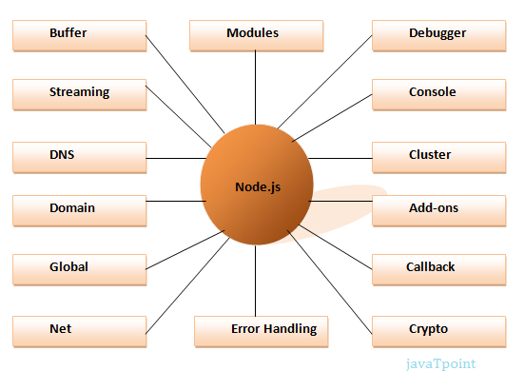

## Features of Node.js

Following is a list of some important features of Node.js that makes it the first choice of software architects.

1. **Extremely fast:**Node.js is built on Google Chrome's V8 JavaScript Engine, so its library is very fast in code execution.
2. **I/O is Asynchronous and Event Driven:**All APIs of Node.js library are asynchronous i.e. non-blocking. So a Node.js based server never waits for an API to return data. The server moves to the next API after calling it and a notification mechanism of Events of Node.js helps the server to get a response from the previous API call. It is also a reason that it is very fast.
3. **Single threaded:**Node.js follows a single threaded model with event looping.
4. **Highly Scalable:**Node.js is highly scalable because event mechanism helps the server to respond in a non-blocking way.
5. **No buffering:**Node.js cuts down the overall processing time while uploading audio and video files. Node.js applications never buffer any data. These applications simply output the data in chunks.
6. **Open source:**Node.js has an open source community which has produced many excellent modules to add additional capabilities to Node.js applications.

## What is Express.js?

Express is a fast, assertive, essential and moderate web framework of Node.js. You can assume express as a layer built on the top of the Node.js that helps manage a server and routes. It provides a robust set of features to develop web and mobile applications.

Let's see some of the core features of Express framework:

* It can be used to design single-page, multi-page and hybrid web applications.
* It allows to setup middlewares to respond to HTTP Requests.
* It defines a routing table which is used to perform different actions based on HTTP method and URL.
* It allows to dynamically render HTML Pages based on passing arguments to templates.

## Why use Express

* Ultra fast I/O
* Asynchronous and single threaded
* MVC like structure
* Robust API makes routing easy

## How does Express look like

Let's see a basic Express.js app.

**File: basic_express.js**

1. var express = require('express');
2. var app = express();
3. app.get('/', function (req, res) {
4. res.send('Welcome to JavaTpoint!');
5. });
6. var server = app.listen(8000, function () {
7. var host = server.address().address;
8. var port = server.address().port;
9. console.log('Example app listening at http://%s:%s', host, port);
10. });

SOURCES CODE

   <!DOCTYPE html>

<html lang="en">

<head>

    <meta charset="UTF-8">

    <meta http-equiv="X-UA-Compatible" content="IE=edge">

    <meta name="viewport" content="width=device-width, initial-scale=1.0">

    <title>Document</title>

    <link href="https://cdn.jsdelivr.net/npm/bootstrap@5.2.2/dist/css/bootstrap.min.css" rel="stylesheet"

        integrity="sha384-Zenh87qX5JnK2Jl0vWa8Ck2rdkQ2Bzep5IDxbcnCeuOxjzrPF/et3URy9Bv1WTRi" crossorigin="anonymous">

    <link rel="stylesheet" href="./css/style.css">

    <link rel="stylesheet" href="https://cdnjs.cloudflare.com/ajax/libs/font-awesome/5.15.4/css/all.min.css">

    <link rel="stylesheet" href="http://maxcdn.bootstrapcdn.com/font-awesome/4.2.0/css/font-awesome.min.css">

    <link rel="stylesheet" href="https://cdnjs.cloudflare.com/ajax/libs/OwlCarousel2/2.3.4/assets/owl.carousel.min.css" integrity="sha512-tS3S5qG0BlhnQROyJXvNjeEM4UpMXHrQfTGmbQ1gKmelCxlSEBUaxhRBj/EFTzpbP4RVSrpEikbmdJobCvhE3g==" crossorigin="anonymous" referrerpolicy="no-referrer" />

    <link rel="stylesheet" href="https://cdnjs.cloudflare.com/ajax/libs/OwlCarousel2/2.3.4/assets/owl.theme.default.min.css" integrity="sha512-sMXtMNL1zRzolHYKEujM2AqCLUR9F2C4/05cdbxjjLSRvMQIciEPCQZo++nk7go3BtSuK9kfa/s+a4f4i5pLkw==" crossorigin="anonymous" referrerpolicy="no-referrer" />

    <!-- ===== CSS ===== -->

    <link rel="stylesheet" href="./Himanshu/style.css">

</head>

<body>

    <header class="header">

        <div class="logo">

            <h3>Fortune<span>Maker</span></h3>

        </div>

        <nav class="navbar">

            <a href="#home">home</a>

            <a href="#about">about</a>

            <a href="#resources">resources</a>

            <a href="#job">job</a>

            <!-- <a href="#quiz">Quiz</a> -->

            <a href="#our-team">Our Team</a>

            <a href="#contact">contact</a>

        </nav>

        <div class="icons">

            <div class="fas fa-search" id="search-btn"></div>

            <div class="fas fa-bars" id="menu-btn"></div>

        </div>

        <div class="search-form">

            <input type="search" id="search-box" placeholder="Search here...">

            <label for="search-box" class="fas fa-search"></label>

        </div>

        <!-- <div class="sign">

            <div class="btn in">Sign In</div>

            <div class="btn up">Sign Up</div>

        </div> -->

    </header>

    <!-- <div class="user-form">

        <div class="modalForm">

            <div class="fas fa-close" id="cross-btn"></div>

            <form action="" class="signUp">

                <div class="inputGroup">

                    <input type="text" name="" id="" placeholder="Name">

                </div>

                <div class="inputGroup">

                    <input type="text" name="" id="" placeholder="University Roll No.">

                </div>

                <div class="inputGroup">

                    <input type="text" name="" id="" placeholder="Email Address">

                </div>

                <div class="inputGroup">

                    <input type="text" name="" id="" placeholder="New Password">

                </div>

                <div class="inputGroup">

                    <input type="text" name="" id="" placeholder="Confirm Password">

                </div>

                <button type="submit" class="btn">Sign Up</button>

            </form>

            <form action="" class="signIn">

                <div class="inputGroup">

                    <input type="text" name="" id="" placeholder="Email Address">

                </div>

                <div class="inputGroup">

                    <input type="text" name="" id="" placeholder="Password">

                </div>

                <button type="submit" class="btn">Sign In</button>

            </form>

        </div>

    </div> -->

    <section class="home" id="home">

        <div class="content">

            <h2>Teachers open the door, but you must <span>enter by yourself.</span></h2>

            <p>Lorem ipsum, dolor sit amet consectetur adipisicing elit. Placeat labore, sint cupiditate distinctio

                tempora reiciendis.</p>

            <a href="#" class="btn">subscribe us</a>

        </div>

    </section>

    <section id="about" >

        <div class="section-about">

            <div class="container-about">

                <div class="title">

                    <h1>About Fortune Maker</h1>

                </div>

                <div class="content-section">

                    <div class="content">

                        <h3>Site that connects Seeker to keeper !</h3>

                        <p>We are here to save you from "Oops !" or "What if!".We provide you with each and every update of the ongoing and upcoming events,

                            So you would never miss any chance to race your fingers on keyboard or to race you feet on the dance floor. So stay tuned and pull up your socks for the next mega Dhamaka!!! </p>

                            <br>

                            <br>

                        <div class="button">

                            <a href="./pages/aboutTeam.html">Read More</a>

                        </div>

                    </div>

                    <div class="social">

                        <a href=""><i class="fab fa-facebook-f"></i></a>

                        <a href=""><i class="fab fa-twitter"></i></a>

                        <a href=""><i class="fab fa-instagram"></i></a>

                    </div>

                </div>

                <div class="image-section">

                    <video controls loop autoplay src="./video/WhatsApp Video 2022-07-27 at 11.55.34 AM.mp4"></video>

                </div>

            </div>

        </div>

    </section>

    <h2 id="heading">Resources</h2>

    <section class="card-section">

        <div class="container">

            <h2>Data Structures</h2>

            <div class="card">

                <div class="front">

                    <div class="img">

                        <img src="https://www.freecodecamp.org/news/content/images/2021/06/1_s6hhrgR5_tXpO_j7uKaHMw-1.png" alt="">

                    </div>

                    <!-- <h3>Data Structures</h3> -->

                </div>

                <div class="back">

                    <!-- <h3>Data Structures</h3> -->

                    <p>Lorem ipsum, dolor sit amet consectetur adipisicing elit. At quidem dolore nisi velit.</p>

                    <div class="btn">

                        <a href="https://drive.google.com/drive/folders/1cmSWUeoUhS_FZ-bgi1ytXO0P40LZ66lR?usp=share_link" target="_blank">Learn More</a>

                    </div>

                    <div class="btn" onclick="load('dsa')">

                        Videos

                    </div>

                </div>

            </div>

        </div>

        <div class="container">

            <h2>Discrete Maths</h2>

            <div class="card">

                <div class="front">

                    <div class="img">

                        <img src="https://previews.123rf.com/images/radiantskies/radiantskies1211/radiantskies121100041/16084060-abstract-word-cloud-for-discrete-mathematics-with-related-tags-and-terms.jpg" alt="">

                    </div>

                    <!-- <h3>Discrete Maths</h3> -->

                </div>

                <div class="back">

                    <!-- <h3>Discrete Maths</h3> -->

                    <p>Lorem ipsum, dolor sit amet consectetur adipisicing elit. At quidem dolore nisi velit.</p>

                    <div class="btn">

                        <a href="https://drive.google.com/drive/folders/10kIB_hxW9ydIZZtuyTk9PQdLly-Lr5Z4?usp=share_link" target="_blank">Learn More</a>

                    </div>

                    <div class="btn" onclick="load('discrete')">

                        Videos

                    </div>

                </div>

            </div>

        </div>

        <div class="container">

            <h2>Microprocessor</h2>

            <div class="card">

                <div class="front">

                    <div class="img">

                        <img src="https://cloudfront-us-east-1.images.arcpublishing.com/coindesk/UJP73H47EBD35J6LK26NECNWN4.jpg" alt="">

                    </div>

                    <!-- <h3>Microprocessor</h3> -->

                </div>

                <div class="back">

                    <!-- <h3>Microprocessor</h3> -->

                    <p>Lorem ipsum, dolor sit amet consectetur adipisicing elit. At quidem dolore nisi velit.</p>

                    <div class="btn">

                        <a href="https://drive.google.com/drive/folders/1QPeog-qdTySEwKkXAG0bIwrtpVslcGW-?usp=share_link" target="_blank">Learn More</a>

                    </div>

                    <div class="btn" onclick="load('microprocessor')">

                        Videos

                    </div>

                </div>

            </div>

        </div>

        <div class="container">

            <h2>DBMS</h2>

            <div class="card">

                <div class="front">

                    <div class="img">

                        <img src="https://thumbs.dreamstime.com/z/dbms-line-art-concept-vector-database-management-systemt-round-banner-web-resources-programming-server-elements-77290437.jpg" alt="">

                    </div>

                    <!-- <h3>Database Management System</h3> -->

                </div>

                <div class="back">

                    <!-- <h3>Database Management System</h3> -->

                    <p>Lorem ipsum, dolor sit amet consectetur adipisicing elit. At quidem dolore nisi velit.</p>

                    <div class="btn">

                        <a href="https://drive.google.com/drive/folders/1ypcLTIOhxW0nVGwNPc2uh5oSZBgHM54x?usp=share_link" target="_blank">Learn More</a>

                    </div>

                    <div class="btn" onclick="load('dbms')">

                        Videos

                    </div>

                </div>

            </div>

        </div>

    </section>

    <div class="card-section btn" id="load-more-btn"> <a href="./html/resourses.html" target="_blank"> Explore Courses </a></div>

    <h2 id="heading">OUR TEAM</h2>

    <div class="main">

        <div class="profile-card">

            <div class="img">

                <img src="./images/vaibhav.png">

            </div>

            <div class="caption">

                <h3>Vaibhav Varshney</h3>

                <p>Full Stack Developer</p>

                <div class="social-links">

                    <a href="#"><i class="fab fa-facebook"></i></a>

                    <a href="#"><i class="fab fa-instagram"></i></a>

                    <a href="#"><i class="fab fa-twitter"></i></a>

                </div>

            </div>

        </div>

        <div class="profile-card">

            <div class="img">

                <img src="./images/santosh.png">

            </div>

            <div class="caption">

                <h3>Santosh Mourya</h3>

                <p>Full Stack Developer</p>

                <div class="social-links">

                    <a href="#"><i class="fab fa-facebook"></i></a>

                    <a href="#"><i class="fab fa-instagram"></i></a>

                    <a href="#"><i class="fab fa-twitter"></i></a>

                </div>

            </div>

        </div>

        <div class="profile-card">

            <div class="img">

                <img src="./images/himanshu.png">

            </div>

            <div class="caption">

                <h3>Himanshu Khuswaha</h3>

                <p>Full Stack Developer</p>

                <div class="social-links">

                    <a href="#"><i class="fab fa-facebook"></i></a>

                    <a href="#"><i class="fab fa-instagram"></i></a>

                    <a href="#"><i class="fab fa-twitter"></i></a>

                </div>

            </div>

        </div>

        <div class="profile-card">

            <div class="img">

                <img src="./images/mradul.png">

            </div>

            <div class="caption">

                <h3>Mradul Varshney</h3>

                <p>Full Stack Developer</p>

                <div class="social-links">

                    <a href="#"><i class="fab fa-facebook"></i></a>

                    <a href="#"><i class="fab fa-instagram"></i></a>

                    <a href="#"><i class="fab fa-twitter"></i></a>

                </div>

            </div>

        </div>

        <div class="profile-card">

            <div class="img">

                <img src="./images/garima.png">

            </div>

            <div class="caption">

                <h3>Garima Gautam</h3>

                <p>Full Stack Developer</p>

                <div class="social-links">

                    <a href="#"><i class="fab fa-facebook"></i></a>

                    <a href="#"><i class="fab fa-instagram"></i></a>

                    <a href="#"><i class="fab fa-twitter"></i></a>

                </div>

            </div>

        </div>

    </div>

    <footer class="footer-distributed">

        <div class="footer-left">

            <h3>Fortune<span>Maker</span></h3>

            <p class="footer-links">

                <a href="#">Home</a>

                |

                <a href="#">About</a>

                |

                <a href="#">Contact</a>

                |

                <a href="#">Blog</a>

            </p>

            <p class="footer-company-name">Copyright © 2022 <strong>Fortune Maker</strong> All rights reserved</p>

        </div>

        <div class="footer-center">

            <div>

                <i class="fa fa-map-marker"></i>

                <p>GLA University, Mathura</p>

            </div>

            <div>

                <i class="fa fa-phone"></i>

                <p>+91 819*****43</p>

            </div>

            <div>

                <i class="fa fa-envelope"></i>

                <p><a href="">fortune.maker@gmail.com</a></p>

            </div>

        </div>

        <div class="footer-right">

            <p class="footer-company-about">

                <span>About the company</span>

                <strong>Fortune Maker</strong> is a Lorem ipsum dolor sit amet consectetur adipisicing elit. Sequi, delectus Lorem ipsum dolor sit amet consectetur adipisicing elit. Perferendis atque quis

            </p>

            <div class="footer-icons">

                <a href="#"><i class="fa fa-facebook"></i></a>

                <a href="#"><i class="fa fa-instagram"></i></a>

                <a href="#"><i class="fa fa-linkedin"></i></a>

                <a href="#"><i class="fa fa-twitter"></i></a>

                <a href="#"><i class="fa fa-youtube"></i></a>

            </div>

        </div>

    </footer>

<div class="body dsa">

        <section class="videos">

            <div class="fas fa-close v-cross-btn" onclick="closed('dsa')"></div>

            <div class="owl-carousel owl-theme">

                <div class="item">

                    <div class="swiper-slide card">

                        <div class="card-content">

                            <div class="image">

                                <img src="./Himanshu/img/Anuj Bhaiya.jpg" alt="">

                            </div>

                            <div class="name-profession">

                                <span class="name">Anuj Bhaiya</span>

                            </div>

                            <div class="button">

                                <button class="hireMe">Get Videos</button>

                            </div>

                        </div>

                    </div>

                </div>

                <div class="item"><h4>2</h4></div>

                <div class="item"><h4>3</h4></div>

                <div class="item"><h4>4</h4></div>

                <div class="item"><h4>5</h4></div>

            </div>

        </section>

    </div>

    <div class="body discrete">

        <section class="videos">

            <div class="fas fa-close v-cross-btn" onclick="closed('discrete')"></div>

            <div class="owl-carousel owl-theme">

                <div class="item">

                    <div class="swiper-slide card">

                        <div class="card-content">

                            <div class="image">

                                <img src="./Himanshu/img/Anuj Bhaiya.jpg" alt="">

                            </div>

                            <div class="name-profession">

                                <span class="name">Anuj Bhaiya</span>

                            </div>

                            <div class="button">

                                <button class="hireMe">Get Videos</button>

                            </div>

                        </div>

                    </div>

                </div>

                <div class="item"><h4>2</h4></div>

                <div class="item"><h4>3</h4></div>

                <div class="item"><h4>4</h4></div>

                <div class="item"><h4>5</h4></div>

            </div>

        </section>

    </div>

    <div class="body microprocessor">

        <section class="videos">

            <div class="fas fa-close v-cross-btn" onclick="closed('microprocessor')"></div>

            <div class="owl-carousel owl-theme">

                <div class="item">

                    <div class="swiper-slide card">

                        <div class="card-content">

                            <div class="image">

                                <img src="./Himanshu/img/garima.png" alt="">

                            </div>

                            <div class="name-profession">

                                <span class="name">Anuj Bhaiya</span>

                            </div>

                            <div class="button">

                                <button class="hireMe">Get Videos</button>

                            </div>

                        </div>

                    </div>

                </div>

                <div class="item"><h4>2</h4></div>

                <div class="item"><h4>3</h4></div>

                <div class="item"><h4>4</h4></div>

                <div class="item"><h4>5</h4></div>

            </div>

        </section>

    </div>

    <div class="body dbms">

        <section class="videos">

            <div class="fas fa-close v-cross-btn" onclick="closed('dbms')"></div>

            <div class="owl-carousel owl-theme">

                <div class="item">

                    <div class="swiper-slide card">

                        <div class="card-content">

                            <div class="image">

                                <img src="./Himanshu/img/garima.png" alt="">

                            </div>

                            <div class="name-profession">

                                <span class="name">Anuj Bhaiya</span>

                            </div>

                            <div class="button">

                                <button class="hireMe">Get Videos</button>

                            </div>

                        </div>

                    </div>

                </div>

                <div class="item"><h4>2</h4></div>

                <div class="item"><h4>3</h4></div>

                <div class="item"><h4>4</h4></div>

                <div class="item"><h4>5</h4></div>

            </div>

        </section>

    </div>

    <script src="https://cdnjs.cloudflare.com/ajax/libs/jquery/3.5.1/jquery.min.js" integrity="sha512-bLT0Qm9VnAYZDflyKcBaQ2gg0hSYNQrJ8RilYldYQ1FxQYoCLtUjuuRuZo+fjqhx/qtq/1itJ0C2ejDxltZVFg==" crossorigin="anonymous" referrerpolicy="no-referrer"></script>

    <script src="https://cdnjs.cloudflare.com/ajax/libs/OwlCarousel2/2.3.4/owl.carousel.min.js" integrity="sha512-bPs7Ae6pVvhOSiIcyUClR7/q2OAsRiovw4vAkX+zJbw3ShAeeqezq50RIIcIURq7Oa20rW2n2q+fyXBNcU9lrw==" crossorigin="anonymous" referrerpolicy="no-referrer"></script>

    <script type="text/javascript">

        $('.owl-carousel').owlCarousel({

            loop:true,

            margin:10,

            nav:true,

            dots:false,

            responsive:{

                0:{

                    items:1

                },

                600:{

                    items:2

                },

                1000:{

                    items:3

                }

            }

        })

    </script>

    <script src="https://cdn.jsdelivr.net/npm/bootstrap@5.2.2/dist/js/bootstrap.bundle.min.js"

        integrity="sha384-OERcA2EqjJCMA+/3y+gxIOqMEjwtxJY7qPCqsdltbNJuaOe923+mo//f6V8Qbsw3"

        crossorigin="anonymous"></script>

    <script src="./js/script.js"></script>

</div>

</html>

<!DOCTYPE html>

<html lang="en">

<head>

    <meta charset="UTF-8">

    <meta http-equiv="X-UA-Compatible" content="IE=edge">

    <meta name="viewport" content="width=device-width, initial-scale=1.0">

    <title>Resources</title>

    <link rel="stylesheet" href="../css/style.css">

    <link rel="stylesheet" href="../css/resourses.css">

    <link rel="stylesheet" href="https://cdnjs.cloudflare.com/ajax/libs/font-awesome/5.15.4/css/all.min.css">

    <link rel="stylesheet" href="http://maxcdn.bootstrapcdn.com/font-awesome/4.2.0/css/font-awesome.min.css">

    <link rel="stylesheet" href="https://cdnjs.cloudflare.com/ajax/libs/OwlCarousel2/2.3.4/assets/owl.carousel.min.css" integrity="sha512-tS3S5qG0BlhnQROyJXvNjeEM4UpMXHrQfTGmbQ1gKmelCxlSEBUaxhRBj/EFTzpbP4RVSrpEikbmdJobCvhE3g==" crossorigin="anonymous" referrerpolicy="no-referrer" />

    <link rel="stylesheet" href="https://cdnjs.cloudflare.com/ajax/libs/OwlCarousel2/2.3.4/assets/owl.theme.default.min.css" integrity="sha512-sMXtMNL1zRzolHYKEujM2AqCLUR9F2C4/05cdbxjjLSRvMQIciEPCQZo++nk7go3BtSuK9kfa/s+a4f4i5pLkw==" crossorigin="anonymous" referrerpolicy="no-referrer" />

    <!-- ===== CSS ===== -->

    <link rel="stylesheet" href="../Himanshu/style.css">

</head>

<body>

    <header class="header">

        <div class="logo">

            <h3>Fortune<span>Maker</span></h3>

        </div>

        <nav class="navbar">

            <a href="#home">home</a>

            <a href="#about">about</a>

            <a href="#resources">resources</a>

            <a href="#job">job</a>

            <!-- <a href="#quiz">Quiz</a> -->

            <a href="#our-team">Our Team</a>

            <a href="#contact">contact</a>

        </nav>

        <div class="icons">

            <div class="fas fa-search" id="search-btn"></div>

            <div class="fas fa-bars" id="menu-btn"></div>

        </div>

        <div class="search-form">

            <input type="search" id="search-box" placeholder="Search here...">

            <label for="search-box" class="fas fa-search"></label>

        </div>

        <!-- <div class="sign">

            <div class="btn in">Sign In</div>

            <div class="btn up">Sign Up</div>

        </div> -->

    </header>

    <div class="resourse">

        <h2 id="heading">Resources</h2>

        <div>

            <h1>1st Year</h1>

            <section class="card-section">

                <div class="container">

                    <h2>C Programming</h2>

                    <div class="card">

                        <div class="front">

                            <div class="img">

                                <img src="../images/C Programming.png" alt="">

                            </div>

                            <!-- <h3>Data Structures</h3> -->

                        </div>

                        <div class="back">

                            <!-- <h3>Data Structures</h3> -->

                            <p>Lorem ipsum, dolor sit amet consectetur adipisicing elit. At quidem dolore nisi velit.</p>

                            <div class="btn">

                                <a href="https://drive.google.com/drive/folders/1Xw9hmxRy7OFNmV775emwhuig3MapClDR?usp=share_link" target="_blank">Learn More</a>

                            </div>

                            <div class="btn" onclick="load('c-programming')">

                                Videos

                            </div>

                        </div>

                    </div>

                </div>

                <div class="container">

                    <h2>Electronics</h2>

                    <div class="card">

                        <div class="front">

                            <div class="img">

                                <img src="https://previews.123rf.com/images/radiantskies/radiantskies1211/radiantskies121100041/16084060-abstract-word-cloud-for-discrete-mathematics-with-related-tags-and-terms.jpg" alt="">

                            </div>

                            <!-- <h3>Discrete Maths</h3> -->

                        </div>

                        <div class="back">

                            <!-- <h3>Discrete Maths</h3> -->

                            <p>Lorem ipsum, dolor sit amet consectetur adipisicing elit. At quidem dolore nisi velit.</p>

                            <div class="btn">

                                <a href="https://drive.google.com/drive/folders/1D_65G_3dWuEdrPt2_B8EPLuZP4AdSzqn?usp=share_link" target="_blank">Learn More</a>

                            </div>

                            <div class="btn" onclick="load('electronics')">

                                Videos

                            </div>

                        </div>

                    </div>

                </div>

                <div class="container">

                    <h2>English 1</h2>

                    <div class="card">

                        <div class="front">

                            <div class="img">

                                <img src="../images/English.jpg" alt="">

                            </div>

                            <!-- <h3>Microprocessor</h3> -->

                        </div>

                        <div class="back">

                            <!-- <h3>Microprocessor</h3> -->

                            <p>Lorem ipsum, dolor sit amet consectetur adipisicing elit. At quidem dolore nisi velit.</p>

                            <div class="btn">

                                <a href="https://drive.google.com/drive/folders/1867QF_5LXN1stWarAWNdLE9-TPTB2EL7?usp=share_link" target="_blank">Learn More</a>

                            </div>

                            <!-- <div class="btn" onclick="load('english-1')">

                                Videos

                            </div> -->

                        </div>

                    </div>

                </div>

                <div class="container">

                    <h2>Eng. Maths</h2>

                    <div class="card">

                        <div class="front">

                            <div class="img">

                                <img src="../images/math.jpg" alt="">

                            </div>

                            <!-- <h3>Database Management System</h3> -->

                        </div>

                        <div class="back">

                            <!-- <h3>Database Management System</h3> -->

                            <p>Lorem ipsum, dolor sit amet consectetur adipisicing elit. At quidem dolore nisi velit.</p>

                            <div class="btn">

                                <a href="https://drive.google.com/drive/folders/1Cz0ZRnIdoXiGUDE-Xl7aNiTOxcytCftB?usp=share_link" target="_blank">Learn More</a>

                            </div>

                            <div class="btn" onclick="load('eng-maths')">

                                Videos

                            </div>

                        </div>

                    </div>

                </div>

                <div class="container">

                    <h2>Physics</h2>

                    <div class="card">

                        <div class="front">

                            <div class="img">

                                <img src="../images/physics.jpg" alt="">

                            </div>

                            <!-- <h3>Computer Network</h3> -->

                        </div>

                        <div class="back">

                            <!-- <h3>Computer Network</h3> -->

                            <p>Lorem ipsum, dolor sit amet consectetur adipisicing elit. At quidem dolore nisi velit.</p>

                            <div class="btn">

                                <a href="https://drive.google.com/drive/folders/1GuhJPKl24ji03n5VBC0_r0EeuaGyDBen?usp=share_link" target="_blank">Learn More</a>

                            </div>

                            <div class="btn" onclick="load('physics')">

                                Videos

                            </div>

                        </div>

                    </div>

                </div>

                <div class="container">

                    <h2>Electrical</h2>

                    <div class="card">

                        <div class="front">

                            <div class="img">

                                <img src="../images/electrical-engineering.jpg" alt="">

                            </div>

                            <!-- <h3>Computer Organisation</h3> -->

                        </div>

                        <div class="back">

                            <!-- <h3>Computer Organisation</h3> -->

                            <p>Lorem ipsum, dolor sit amet consectetur adipisicing elit. At quidem dolore nisi velit.</p>

                            <div class="btn">

                                <a href="https://drive.google.com/drive/folders/13-TJ-gHj5u6fti3GCBz5IWQV8dyXY6aM?usp=share_link" target="_blank">Learn More</a>

                            </div>

                            <div class="btn" onclick="load('electrical')">

                                Videos

                            </div>

                        </div>

                    </div>

                </div>

                <div class="container">

                    <h2>Mechanical</h2>

                    <div class="card">

                        <div class="front">

                            <div class="img">

                                <img src="../images/mechanical.jpg" alt="">

                            </div>

                            <!-- <h3>Java</h3> -->

                        </div>

                        <div class="back">

                            <!-- <h3>Java</h3> -->

                            <p>Lorem ipsum, dolor sit amet consectetur adipisicing elit. At quidem dolore nisi velit.</p>

                            <div class="btn">

                                <a href="https://drive.google.com/drive/folders/1LSQf1DY5QrzErWCoKkt-gb-9Kltq7Kfs?usp=share_link" target="_blank">Learn More</a>

                            </div>

                            <div class="btn" onclick="load('mechanical')">

                                Videos

                            </div>

                        </div>

                    </div>

                </div>

                <div class="container">

                    <h2>Chemistry</h2>

                    <div class="card">

                        <div class="front">

                            <div class="img">

                                <img src="../images/chemistry.jpg" alt="">

                            </div>

                            <!-- <h3>Operating System</h3> -->

                        </div>

                        <div class="back">

                            <!-- <h3>Operating System</h3> -->

                            <p>Lorem ipsum, dolor sit amet consectetur adipisicing elit. At quidem dolore nisi velit.</p>

                            <div class="btn">

                                <a href="https://drive.google.com/drive/folders/10IZyYF-k0s_RGL1nUr7C9DZQ5NiNlm6s?usp=share_link" target="_blank">Learn More</a>

                            </div>

                            <div class="btn" onclick="load('chemistry')">

                                Videos

                            </div>

                        </div>

                    </div>

                </div>

                <div class="container">

                    <h2>English 2</h2>

                    <div class="card">

                        <div class="front">

                            <div class="img">

                                <img src="../images/English.jpg" alt="">

                            </div>

                            <!-- <h3>Software Engineering</h3> -->

                        </div>

                        <div class="back">

                            <!-- <h3>Software Engineering</h3> -->

                            <p>Lorem ipsum, dolor sit amet consectetur adipisicing elit. At quidem dolore nisi velit.</p>

                            <div class="btn">

                                <a href="https://drive.google.com/drive/folders/12WX9SujV50QUOfs_vyRqZcCeknh7WH-Z?usp=share_link" target="_blank">Learn More</a>

                            </div>

                            <!-- <div class="btn" onclick="load('english-2')">

                                Videos

                            </div> -->

                        </div>

                    </div>

                </div>

                <div class="container">

                    <h2>Eng. Maths 2</h2>

                    <div class="card">

                        <div class="front">

                            <div class="img">

                                <img src="../images/math2.jpg" alt="">

                            </div>

                            <!-- <h3>Software Engineering</h3> -->

                        </div>

                        <div class="back">

                            <!-- <h3>Software Engineering</h3> -->

                            <p>Lorem ipsum, dolor sit amet consectetur adipisicing elit. At quidem dolore nisi velit.</p>

                            <div class="btn">

                                <a href="https://drive.google.com/drive/folders/1PiCdEan626WqSwHKY0ONL4-EYK21xeA6?usp=share_link" target="_blank">Learn More</a>

                            </div>

                            <div class="btn" onclick="load('eng-maths-2')">

                                Videos

                            </div>

                        </div>

                    </div>

                </div>

                <div class="container">

                    <h2>Python</h2>

                    <div class="card">

                        <div class="front">

                            <div class="img">

                                <img src="../images/python.png" alt="">

                            </div>

                            <!-- <h3>Software Engineering</h3> -->

                        </div>

                        <div class="back">

                            <!-- <h3>Software Engineering</h3> -->

                            <p>Lorem ipsum, dolor sit amet consectetur adipisicing elit. At quidem dolore nisi velit.</p>

                            <div class="btn">

                                <a href="https://drive.google.com/drive/folders/1u4GTf6Su4LoBCDxWSVmhubZ0h-henwoz?usp=share_link" target="_blank">Learn More</a>

                            </div>

                            <div class="btn" onclick="load('python')">

                                Videos

                            </div>

                        </div>

                    </div>

                </div>

            </section>

        </div>

        <!-- <hr> -->

        <div>

            <h1>2nd Year</h1>

            <section class="card-section">

                <div class="container">

                    <h2>Data Structures</h2>

                    <div class="card">

                        <div class="front">

                            <div class="img">

                                <img src="https://www.freecodecamp.org/news/content/images/2021/06/1_s6hhrgR5_tXpO_j7uKaHMw-1.png" alt="">

                            </div>

                            <!-- <h3>Data Structures</h3> -->

                        </div>

                        <div class="back">

                            <!-- <h3>Data Structures</h3> -->

                            <p>Lorem ipsum, dolor sit amet consectetur adipisicing elit. At quidem dolore nisi velit.</p>

                            <div class="btn">

                                <a href="https://drive.google.com/drive/folders/1cmSWUeoUhS_FZ-bgi1ytXO0P40LZ66lR?usp=share_link" target="_blank">Learn More</a>

                            </div>

                            <div class="btn" onclick="load('dsa')">

                                Videos

                            </div>

                        </div>

                    </div>

                </div>

                <div class="container">

                    <h2>Discrete Maths</h2>

                    <div class="card">

                        <div class="front">

                            <div class="img">

                                <img src="https://previews.123rf.com/images/radiantskies/radiantskies1211/radiantskies121100041/16084060-abstract-word-cloud-for-discrete-mathematics-with-related-tags-and-terms.jpg" alt="">

                            </div>

                            <!-- <h3>Discrete Maths</h3> -->

                        </div>

                        <div class="back">

                            <!-- <h3>Discrete Maths</h3> -->

                            <p>Lorem ipsum, dolor sit amet consectetur adipisicing elit. At quidem dolore nisi velit.</p>

                            <div class="btn">

                                <a href="https://drive.google.com/drive/folders/10kIB_hxW9ydIZZtuyTk9PQdLly-Lr5Z4?usp=share_link" target="_blank">Learn More</a>

                            </div>

                            <div class="btn" onclick="load('discrete')">

                                Videos

                            </div>

                        </div>

                    </div>

                </div>

                <div class="container">

                    <h2>Microprocessor</h2>

                    <div class="card">

                        <div class="front">

                            <div class="img">

                                <img src="https://cloudfront-us-east-1.images.arcpublishing.com/coindesk/UJP73H47EBD35J6LK26NECNWN4.jpg" alt="">

                            </div>

                            <!-- <h3>Microprocessor</h3> -->

                        </div>

                        <div class="back">

                            <!-- <h3>Microprocessor</h3> -->

                            <p>Lorem ipsum, dolor sit amet consectetur adipisicing elit. At quidem dolore nisi velit.</p>

                            <div class="btn">

                                <a href="https://drive.google.com/drive/folders/1QPeog-qdTySEwKkXAG0bIwrtpVslcGW-?usp=share_link" target="_blank">Learn More</a>

                            </div>

                            <div class="btn" onclick="load('microprocessor')">

                                Videos

                            </div>

                        </div>

                    </div>

                </div>

                <div class="container">

                    <h2>DBMS</h2>

                    <div class="card">

                        <div class="front">

                            <div class="img">

                                <img src="https://thumbs.dreamstime.com/z/dbms-line-art-concept-vector-database-management-systemt-round-banner-web-resources-programming-server-elements-77290437.jpg" alt="">

                            </div>

                            <!-- <h3>Database Management System</h3> -->

                        </div>

                        <div class="back">

                            <!-- <h3>Database Management System</h3> -->

                            <p>Lorem ipsum, dolor sit amet consectetur adipisicing elit. At quidem dolore nisi velit.</p>

                            <div class="btn">

                                <a href="https://drive.google.com/drive/folders/1ypcLTIOhxW0nVGwNPc2uh5oSZBgHM54x?usp=share_link" target="_blank">Learn More</a>

                            </div>

                            <div class="btn" onclick="load('dbms')">

                                Videos

                            </div>

                        </div>

                    </div>

                </div>

                <div class="container">

                    <h2>Computer Network</h2>

                    <div class="card">

                        <div class="front">

                            <div class="img">

                                <img src="https://images.velog.io/images/cksdnr066/post/cbfb1fef-60e0-477a-9e7e-920c528c448f/computer-networking-1024x683.jpg" alt="">

                            </div>

                            <!-- <h3>Computer Network</h3> -->

                        </div>

                        <div class="back">

                            <!-- <h3>Computer Network</h3> -->

                            <p>Lorem ipsum, dolor sit amet consectetur adipisicing elit. At quidem dolore nisi velit.</p>

                            <div class="btn">

                                <a href="https://drive.google.com/drive/folders/1xfYn5nzV_LUFdE-NMqxyj7_eGJ99AV-u?usp=share_link" target="_blank">Learn More</a>

                            </div>

                            <div class="btn" onclick="load('cn')">

                                Videos

                            </div>

                        </div>

                    </div>

                </div>

                <div class="container">

                    <h2>Computer Organisation</h2>

                    <div class="card">

                        <div class="front">

                            <div class="img">

                                <img src="https://d3mxt5v3yxgcsr.cloudfront.net/courses/1961/course_1961_image.png" alt="">

                            </div>

                            <!-- <h3>Computer Organisation</h3> -->

                        </div>

                        <div class="back">

                            <!-- <h3>Computer Organisation</h3> -->

                            <p>Lorem ipsum, dolor sit amet consectetur adipisicing elit. At quidem dolore nisi velit.</p>

                            <div class="btn">

                                <a href="https://drive.google.com/drive/folders/1M0oPvG32WCjL5JBhh_AnlA2EZ0BrRRV2?usp=share_link" target="_blank">Learn More</a>

                            </div>

                            <div class="btn" onclick="load('co')">

                                Videos

                            </div>

                        </div>

                    </div>

                </div>

                <div class="container">

                    <h2>Java</h2>

                    <div class="card">

                        <div class="front">

                            <div class="img">

                                <img src="https://fiverr-res.cloudinary.com/t_main1,q_auto,f_auto/gigs/171875643/original/496b0f89500a77cb825464584e2fea12001740a0.jpg" alt="">

                            </div>

                            <!-- <h3>Java</h3> -->

                        </div>

                        <div class="back">

                            <!-- <h3>Java</h3> -->

                            <p>Lorem ipsum, dolor sit amet consectetur adipisicing elit. At quidem dolore nisi velit.</p>

                            <div class="btn">

                                <a href="https://drive.google.com/drive/folders/1vP-hYKN-52C_-0oeqDISkElJ3q70LKDq?usp=share_link" target="_blank">Learn More</a>

                            </div>

                            <div class="btn" onclick="load('java')">

                                Videos

                            </div>

                        </div>

                    </div>

                </div>

                <div class="container">

                    <h2>Operating System</h2>

                    <div class="card">

                        <div class="front">

                            <div class="img">

                                <img src="https://binarymove.com/wp-content/uploads/2018/11/Operating-System.png" alt="">

                            </div>

                            <!-- <h3>Operating System</h3> -->

                        </div>

                        <div class="back">

                            <!-- <h3>Operating System</h3> -->

                            <p>Lorem ipsum, dolor sit amet consectetur adipisicing elit. At quidem dolore nisi velit.</p>

                            <div class="btn">

                                <a href="https://drive.google.com/drive/folders/1H_WyfaJ34pyws6p4us0gXEOLLEOG1rV2?usp=share_link" target="_blank">Learn More</a>

                            </div>

                            <div class="btn" onclick="load('os')">

                                Videos

                            </div>

                        </div>

                    </div>

                </div>

                <div class="container">

                    <h2>Software Engineering</h2>

                    <div class="card">

                        <div class="front">

                            <div class="img">

                                <img src="https://www.wur.nl/upload/44147869-1a3e-4fa3-ab4a-4f88ffae171d_Educationpage_INF_ss_139233017_800x800%20-%20Blue_Hue-Sat_adjustlayer.jpg" alt="">

                            </div>

                            <!-- <h3>Software Engineering</h3> -->

                        </div>

                        <div class="back">

                            <!-- <h3>Software Engineering</h3> -->

                            <p>Lorem ipsum, dolor sit amet consectetur adipisicing elit. At quidem dolore nisi velit.</p>

                            <div class="btn">

                                <a href="https://drive.google.com/drive/folders/1n8-LdBEOj7yhXTqJKZRn61Z1VVONaz7p?usp=share_link" target="_blank">Learn More</a>

                            </div>

                            <div class="btn" onclick="load('se')">

                                Videos

                            </div>

                        </div>

                    </div>

                </div>

            </section>

        </div>

    </div>

    <footer class="footer-distributed">

        <div class="footer-left">

            <h3>Fortune<span>Maker</span></h3>

            <p class="footer-links">

                <a href="#">Home</a>

                |

                <a href="#">About</a>

                |

                <a href="#">Contact</a>

                |

                <a href="#">Blog</a>

            </p>

            <p class="footer-company-name">Copyright © 2022 <strong>Fortune Maker</strong> All rights reserved</p>

        </div>

        <div class="footer-center">

            <div>

                <i class="fa fa-map-marker"></i>

                <p>GLA University, Mathura</p>

            </div>

            <div>

                <i class="fa fa-phone"></i>

                <p>+91 819*****43</p>

            </div>

            <div>

                <i class="fa fa-envelope"></i>

                <p><a href="">fortune.maker@gmail.com</a></p>

            </div>

        </div>

        <div class="footer-right">

            <p class="footer-company-about">

                <span>About the company</span>

                <strong>Fortune Maker</strong> is a Lorem ipsum dolor sit amet consectetur adipisicing elit. Sequi, delectus Lorem ipsum dolor sit amet consectetur adipisicing elit. Perferendis atque quis

            </p>

            <div class="footer-icons">

                <a href="#"><i class="fa fa-facebook"></i></a>

                <a href="#"><i class="fa fa-instagram"></i></a>

                <a href="#"><i class="fa fa-linkedin"></i></a>

                <a href="#"><i class="fa fa-twitter"></i></a>

                <a href="#"><i class="fa fa-youtube"></i></a>

            </div>

        </div>

    </footer>

    <!-- 1st Year -->

    <div class="body c-programming">

        <section class="videos">

            <div class="fas fa-close v-cross-btn" onclick="closed('c-programming')"></div>

            <div class="owl-carousel owl-theme">

                <div class="item">

                    <div class="swiper-slide card">

                        <div class="card-content">

                            <div class="image">

                                <img src="./Himanshu/img/Anuj Bhaiya.jpg" alt="">

                            </div>

                            <div class="name-profession">

                                <span class="name">Anuj Bhaiya</span>

                            </div>

                            <div class="button">

                                <button class="hireMe"> <a href="https://youtube.com/playlist?list=PLu0W_9lII9aiXlHcLx-mDH1Qul38wD3aR" target="_blank"> Get Videos </a></button>

                            </div>

                        </div>

                    </div>

                </div>

                <div class="item"><h4>2</h4></div>

                <div class="item"><h4>3</h4></div>

                <div class="item"><h4>4</h4></div>

                <div class="item"><h4>5</h4></div>

            </div>

        </section>

    </div>

    <div class="body electronics">

        <section class="videos">

            <div class="fas fa-close v-cross-btn" onclick="closed('electronics')"></div>

            <div class="owl-carousel owl-theme">

                <div class="item">

                    <div class="swiper-slide card">

                        <div class="card-content">

                            <div class="image">

                                <img src="./Himanshu/img/Anuj Bhaiya.jpg" alt="">

                            </div>

                            <div class="name-profession">

                                <span class="name">Anuj Bhaiya</span>

                            </div>

                            <div class="button">

                                <button class="hireMe"> <a href="https://youtu.be/7jaa1rlW7Ak" target="_blank"> Get Videos </a></button>

                            </div>

                        </div>

                    </div>

                </div>

                <div class="item"><h4>2</h4></div>

                <div class="item"><h4>3</h4></div>

                <div class="item"><h4>4</h4></div>

                <div class="item"><h4>5</h4></div>

            </div>

        </section>

    </div>

    <div class="body english-1">

        <section class="videos">

            <div class="fas fa-close v-cross-btn" onclick="closed('english-1')"></div>

            <div class="owl-carousel owl-theme">

                <div class="item">

                    <div class="swiper-slide card">

                        <div class="card-content">

                            <div class="image">

                                <img src="./Himanshu/img/Anuj Bhaiya.jpg" alt="">

                            </div>

                            <div class="name-profession">

                                <span class="name">Anuj Bhaiya</span>

                            </div>

                            <div class="button">

                                <button class="hireMe"> <a href="https://www.youtube.com/playlist?list=PLU6SqdYcYsfINU_Y9CMp1pZ827ZB1U-Xn" target="_blank"> Get Videos </a></button>

                            </div>

                        </div>

                    </div>

                </div>

                <div class="item"><h4>2</h4></div>

                <div class="item"><h4>3</h4></div>

                <div class="item"><h4>4</h4></div>

                <div class="item"><h4>5</h4></div>

            </div>

        </section>

    </div>

    <div class="body eng-maths">

        <section class="videos">

            <div class="fas fa-close v-cross-btn" onclick="closed('eng-maths')"></div>

            <div class="owl-carousel owl-theme">

                <div class="item">

                    <div class="swiper-slide card">

                        <div class="card-content">

                            <div class="image">

                                <img src="./Himanshu/img/Anuj Bhaiya.jpg" alt="">

                            </div>

                            <div class="name-profession">

                                <span class="name">Anuj Bhaiya</span>

                            </div>

                            <div class="button">

                                <button class="hireMe">Get Videos</button>

                            </div>

                        </div>

                    </div>

                </div>

                <div class="item"><h4>2</h4></div>

                <div class="item"><h4>3</h4></div>

                <div class="item"><h4>4</h4></div>

                <div class="item"><h4>5</h4></div>

            </div>

        </section>

    </div>

    <div class="body physics">

        <section class="videos">

            <div class="fas fa-close v-cross-btn" onclick="closed('physics')"></div>

            <div class="owl-carousel owl-theme">

                <div class="item">

                    <div class="swiper-slide card">

                        <div class="card-content">

                            <div class="image">

                                <img src="./Himanshu/img/Anuj Bhaiya.jpg" alt="">

                            </div>

                            <div class="name-profession">

                                <span class="name">Anuj Bhaiya</span>

                            </div>

                            <div class="button">

                                <button class="hireMe"> <a href="https://www.youtube.com/playlist?list=PL-JvKqQx2Atc-7gw0SglqTajukZhc6Azu" target="_blank"> Get Videos </a></button>

                            </div>

                        </div>

                    </div>

                </div>

                <div class="item"><h4>2</h4></div>

                <div class="item"><h4>3</h4></div>

                <div class="item"><h4>4</h4></div>

                <div class="item"><h4>5</h4></div>

            </div>

        </section>

    </div>

    <div class="body electrical">

        <section class="videos">

            <div class="fas fa-close v-cross-btn" onclick="closed('electrical')"></div>

            <div class="owl-carousel owl-theme">

                <div class="item">

                    <div class="swiper-slide card">

                        <div class="card-content">

                            <div class="image">

                                <img src="./Himanshu/img/Anuj Bhaiya.jpg" alt="">

                            </div>

                            <div class="name-profession">

                                <span class="name">Anuj Bhaiya</span>

                            </div>

                            <div class="button">

                                <button class="hireMe"> <a href="https://www.youtube.com/playlist?list=PL9RcWoqXmzaLTYUdnzKhF4bYug3GjGcEc" target="_blank"> Get Videos </a></button>

                            </div>

                        </div>

                    </div>

                </div>

                <div class="item"><h4>2</h4></div>

                <div class="item"><h4>3</h4></div>

                <div class="item"><h4>4</h4></div>

                <div class="item"><h4>5</h4></div>

            </div>

        </section>

    </div>

    <div class="body mechanical">

        <section class="videos">

            <div class="fas fa-close v-cross-btn" onclick="closed('mechanical')"></div>

            <div class="owl-carousel owl-theme">

                <div class="item">

                    <div class="swiper-slide card">

                        <div class="card-content">

                            <div class="image">

                                <img src="./Himanshu/img/Anuj Bhaiya.jpg" alt="">

                            </div>

                            <div class="name-profession">

                                <span class="name">Anuj Bhaiya</span>

                            </div>

                            <div class="button">

                                <button class="hireMe"> <a href="https://www.youtube.com/playlist?list=PLgwJf8NK-2e7Fe4vAYDaL0bpseGNhc9on" target="_blank"> Get Videos </a></button>

                            </div>

                        </div>

                    </div>

                </div>

                <div class="item"><h4>2</h4></div>

                <div class="item"><h4>3</h4></div>

                <div class="item"><h4>4</h4></div>

                <div class="item"><h4>5</h4></div>

            </div>

        </section>

    </div>

    <div class="body chemistry">

        <section class="videos">

            <div class="fas fa-close v-cross-btn" onclick="closed('chemistry')"></div>

            <div class="owl-carousel owl-theme">

                <div class="item">

                    <div class="swiper-slide card">

                        <div class="card-content">

                            <div class="image">

                                <img src="./Himanshu/img/Anuj Bhaiya.jpg" alt="">

                            </div>

                            <div class="name-profession">

                                <span class="name">Anuj Bhaiya</span>

                            </div>

                            <div class="button">

                                <button class="hireMe"> <a href="https://www.youtube.com/playlist?list=PL4BETMztLJZbw5PUGSH8u4GiZOt4NG64x" target="_blank"> Get Videos </a></button>

                            </div>

                        </div>

                    </div>

                </div>

                <div class="item"><h4>2</h4></div>

                <div class="item"><h4>3</h4></div>

                <div class="item"><h4>4</h4></div>

                <div class="item"><h4>5</h4></div>

            </div>

        </section>

    </div>

    <div class="body english-2>

        <section class="videos">

            <div class="fas fa-close v-cross-btn" onclick="closed('english-2')"></div>

            <div class="owl-carousel owl-theme">

                <div class="item">

                    <div class="swiper-slide card">

                        <div class="card-content">

                            <div class="image">

                                <img src="./Himanshu/img/Anuj Bhaiya.jpg" alt="">

                            </div>

                            <div class="name-profession">

                                <span class="name">Anuj Bhaiya</span>

                            </div>

                            <div class="button">

                                <button class="hireMe">Get Videos</button>

                            </div>

                        </div>

                    </div>

                </div>

                <div class="item"><h4>2</h4></div>

                <div class="item"><h4>3</h4></div>

                <div class="item"><h4>4</h4></div>

                <div class="item"><h4>5</h4></div>

            </div>

        </section>

    </div>

    <div class="body eng-maths-2>

        <section class="videos">

            <div class="fas fa-close v-cross-btn" onclick="closed('eng-maths-2')"></div>

            <div class="owl-carousel owl-theme">

                <div class="item">

                    <div class="swiper-slide card">

                        <div class="card-content">

                            <div class="image">

                                <img src="./Himanshu/img/Anuj Bhaiya.jpg" alt="">

                            </div>

                            <div class="name-profession">

                                <span class="name">Anuj Bhaiya</span>

                            </div>

                            <div class="button">

                                <button class="hireMe"> <a href="https://youtube.com/playlist?list=PLu0W_9lII9aiXlHcLx-mDH1Qul38wD3aR" target="_blank"> Get Videos </a></button>" target="_blank"> Get Videos </a></button>

                            </div>

                        </div>

                    </div>

                </div>

                <div class="item"><h4>2</h4></div>

                <div class="item"><h4>3</h4></div>

                <div class="item"><h4>4</h4></div>

                <div class="item"><h4>5</h4></div>

            </div>

        </section>

    </div>

    <div class="body python">

        <section class="videos">

            <div class="fas fa-close v-cross-btn" onclick="closed('python')"></div>

            <div class="owl-carousel owl-theme">

                <div class="item">

                    <div class="swiper-slide card">

                        <div class="card-content">

                            <div class="image">

                                <img src="./Himanshu/img/Anuj Bhaiya.jpg" alt="">

                            </div>

                            <div class="name-profession">

                                <span class="name">Anuj Bhaiya</span>

                            </div>

                            <div class="button">

                                <button class="hireMe"> <a href="https://www.youtube.com/playlist?list=PLsyeobzWxl7poL9JTVyndKe62ieoN-MZ3" target="_blank"> Get Videos </a></button>

                            </div>

                        </div>

                    </div>

                </div>

                <div class="item"><h4>2</h4></div>

                <div class="item"><h4>3</h4></div>

                <div class="item"><h4>4</h4></div>

                <div class="item"><h4>5</h4></div>

            </div>

        </section>

    </div>

    <!-- 2nd Year -->

    <div class="body dsa">

        <section class="videos">

            <div class="fas fa-close v-cross-btn" onclick="closed('dsa')"></div>

            <div class="owl-carousel owl-theme">

                <div class="item">

                    <div class="swiper-slide card">

                        <div class="card-content">

                            <div class="image">

                                <img src="./Himanshu/img/Anuj Bhaiya.jpg" alt="">

                            </div>

                            <div class="name-profession">

                                <span class="name">Anuj Bhaiya</span>

                            </div>

                            <div class="button">

                                <button class="hireMe">Get Videos</button>

                            </div>

                        </div>

                    </div>

                </div>

                <div class="item"><h4>2</h4></div>

                <div class="item"><h4>3</h4></div>

                <div class="item"><h4>4</h4></div>

                <div class="item"><h4>5</h4></div>

            </div>

        </section>

    </div>

    <div class="body discrete">

        <section class="videos">

            <div class="fas fa-close v-cross-btn" onclick="closed('discrete')"></div>

            <div class="owl-carousel owl-theme">

                <div class="item">

                    <div class="swiper-slide card">

                        <div class="card-content">

                            <div class="image">

                                <img src="./Himanshu/img/Anuj Bhaiya.jpg" alt="">

                            </div>

                            <div class="name-profession">

                                <span class="name">Anuj Bhaiya</span>

                            </div>

                            <div class="button">

                                <button class="hireMe">Get Videos</button>

                            </div>

                        </div>

                    </div>

                </div>

                <div class="item"><h4>2</h4></div>

                <div class="item"><h4>3</h4></div>

                <div class="item"><h4>4</h4></div>

                <div class="item"><h4>5</h4></div>

            </div>

        </section>

    </div>

    <div class="body microprocessor">

        <section class="videos">

            <div class="fas fa-close v-cross-btn" onclick="closed('microprocessor')"></div>

            <div class="owl-carousel owl-theme">

                <div class="item">

                    <div class="swiper-slide card">

                        <div class="card-content">

                            <div class="image">

                                <img src="./Himanshu/img/Anuj Bhaiya.jpg" alt="">

                            </div>

                            <div class="name-profession">

                                <span class="name">Anuj Bhaiya</span>

                            </div>

                            <div class="button">

                                <button class="hireMe">Get Videos</button>

                            </div>

                        </div>

                    </div>

                </div>

                <div class="item"><h4>2</h4></div>

                <div class="item"><h4>3</h4></div>

                <div class="item"><h4>4</h4></div>

                <div class="item"><h4>5</h4></div>

            </div>

        </section>

    </div>

    <div class="body cn">

        <section class="videos">

            <div class="fas fa-close v-cross-btn" onclick="closed('cn')"></div>

            <div class="owl-carousel owl-theme">

                <div class="item">

                    <div class="swiper-slide card">

                        <div class="card-content">

                            <div class="image">

                                <img src="./Himanshu/img/Anuj Bhaiya.jpg" alt="">

                            </div>

                            <div class="name-profession">

                                <span class="name">Anuj Bhaiya</span>

                            </div>

                            <div class="button">

                                <button class="hireMe">Get Videos</button>

                            </div>

                        </div>

                    </div>

                </div>

                <div class="item"><h4>2</h4></div>

                <div class="item"><h4>3</h4></div>

                <div class="item"><h4>4</h4></div>

                <div class="item"><h4>5</h4></div>

            </div>

        </section>

    </div>

    <div class="body co">

        <section class="videos">

            <div class="fas fa-close v-cross-btn" onclick="closed('co')"></div>

            <div class="owl-carousel owl-theme">

                <div class="item">

                    <div class="swiper-slide card">

                        <div class="card-content">

                            <div class="image">

                                <img src="./Himanshu/img/Anuj Bhaiya.jpg" alt="">

                            </div>

                            <div class="name-profession">

                                <span class="name">Anuj Bhaiya</span>

                            </div>

                            <div class="button">

                                <button class="hireMe">Get Videos</button>

                            </div>

                        </div>

                    </div>

                </div>

                <div class="item"><h4>2</h4></div>

                <div class="item"><h4>3</h4></div>

                <div class="item"><h4>4</h4></div>

                <div class="item"><h4>5</h4></div>

            </div>

        </section>

    </div>

    <div class="body java">

        <section class="videos">

            <div class="fas fa-close v-cross-btn" onclick="closed('java')"></div>

            <div class="owl-carousel owl-theme">

                <div class="item">

                    <div class="swiper-slide card">

                        <div class="card-content">

                            <div class="image">

                                <img src="./Himanshu/img/Anuj Bhaiya.jpg" alt="">

                            </div>

                            <div class="name-profession">

                                <span class="name">Anuj Bhaiya</span>

                            </div>

                            <div class="button">

                                <button class="hireMe">Get Videos</button>

                            </div>

                        </div>

                    </div>

                </div>

                <div class="item"><h4>2</h4></div>

                <div class="item"><h4>3</h4></div>

                <div class="item"><h4>4</h4></div>

                <div class="item"><h4>5</h4></div>

            </div>

        </section>

    </div>

    <div class="body os">

        <section class="videos">

            <div class="fas fa-close v-cross-btn" onclick="closed('os')"></div>

            <div class="owl-carousel owl-theme">

                <div class="item">

                    <div class="swiper-slide card">

                        <div class="card-content">

                            <div class="image">

                                <img src="./Himanshu/img/Anuj Bhaiya.jpg" alt="">

                            </div>

                            <div class="name-profession">

                                <span class="name">Anuj Bhaiya</span>

                            </div>

                            <div class="button">

                                <button class="hireMe">Get Videos</button>

                            </div>

                        </div>

                    </div>

                </div>

                <div class="item"><h4>2</h4></div>

                <div class="item"><h4>3</h4></div>

                <div class="item"><h4>4</h4></div>

                <div class="item"><h4>5</h4></div>

            </div>

        </section>

    </div>

    <div class="body se">

        <section class="videos">

            <div class="fas fa-close v-cross-btn" onclick="closed('se')"></div>

            <div class="owl-carousel owl-theme">

                <div class="item">

                    <div class="swiper-slide card">

                        <div class="card-content">

                            <div class="image">

                                <img src="./Himanshu/img/Anuj Bhaiya.jpg" alt="">

                            </div>

                            <div class="name-profession">

                                <span class="name">Anuj Bhaiya</span>

                            </div>

                            <div class="button">

                                <button class="hireMe">Get Videos</button>

                            </div>

                        </div>

                    </div>

                </div>

                <div class="item"><h4>2</h4></div>

                <div class="item"><h4>3</h4></div>

                <div class="item"><h4>4</h4></div>

                <div class="item"><h4>5</h4></div>

            </div>

        </section>

    </div>

    <script src="https://cdnjs.cloudflare.com/ajax/libs/jquery/3.5.1/jquery.min.js" integrity="sha512-bLT0Qm9VnAYZDflyKcBaQ2gg0hSYNQrJ8RilYldYQ1FxQYoCLtUjuuRuZo+fjqhx/qtq/1itJ0C2ejDxltZVFg==" crossorigin="anonymous" referrerpolicy="no-referrer"></script>

    <script src="https://cdnjs.cloudflare.com/ajax/libs/OwlCarousel2/2.3.4/owl.carousel.min.js" integrity="sha512-bPs7Ae6pVvhOSiIcyUClR7/q2OAsRiovw4vAkX+zJbw3ShAeeqezq50RIIcIURq7Oa20rW2n2q+fyXBNcU9lrw==" crossorigin="anonymous" referrerpolicy="no-referrer"></script>

    <script type="text/javascript">

        $('.owl-carousel').owlCarousel({

            loop:true,

            margin:10,

            nav:true,

            dots:false,

            responsive:{

                0:{

                    items:1

                },

                600:{

                    items:2

                },

                1000:{

                    items:3

                }

            }

        })

    </script>

    <script src="../js/script.js"></script>

</body>

</html>

**PREVIEWS**

Home page



**Resource Section**

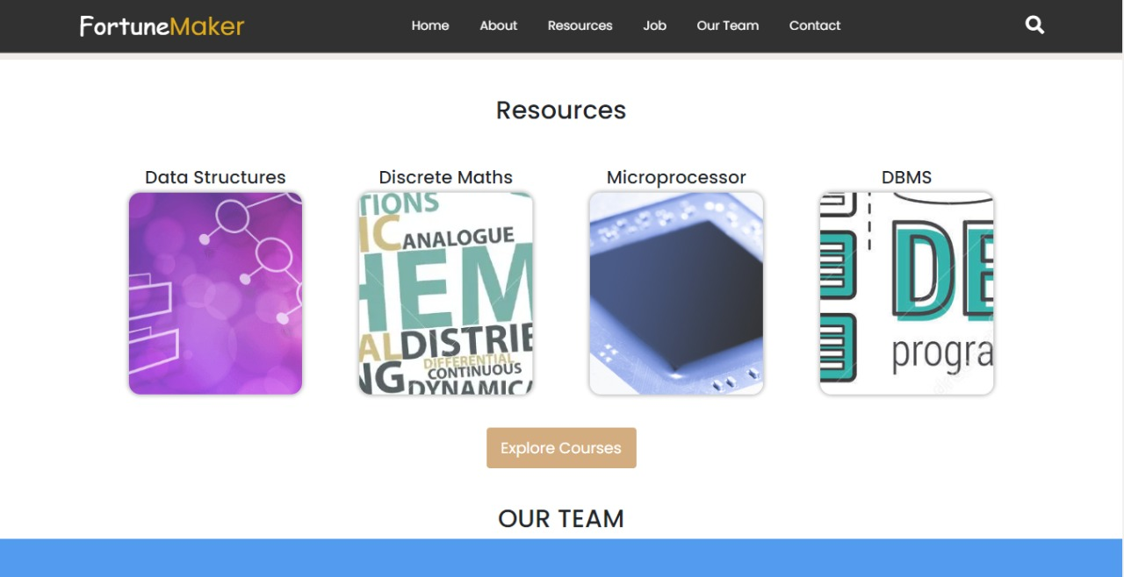

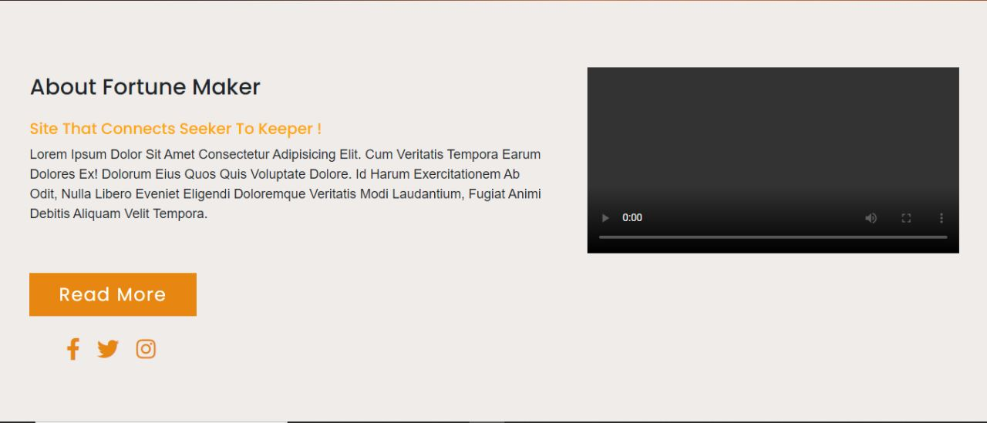

**Sign Up page**

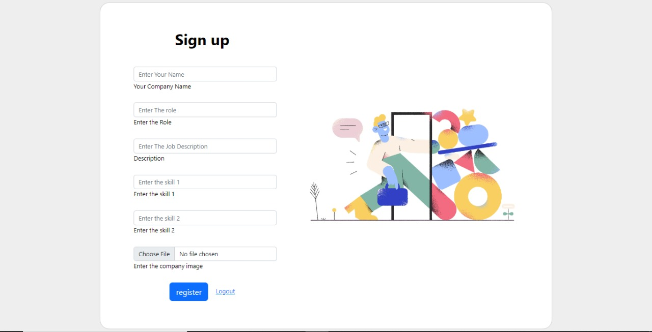

Job portal

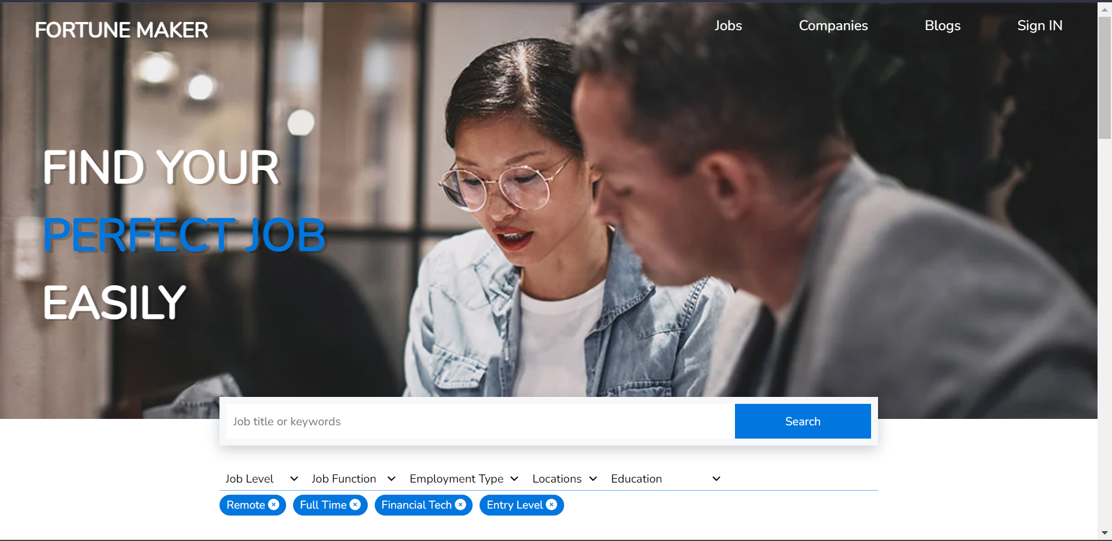

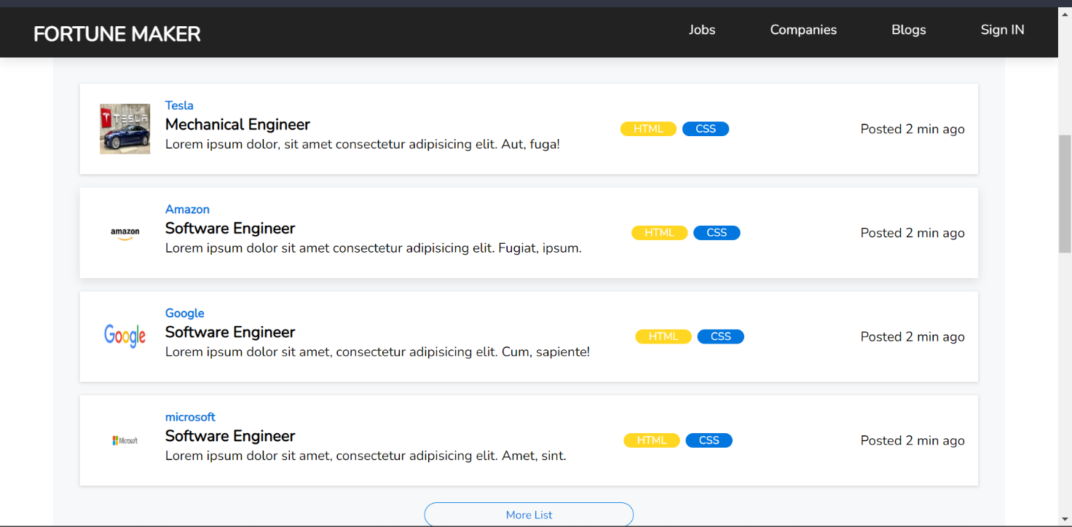

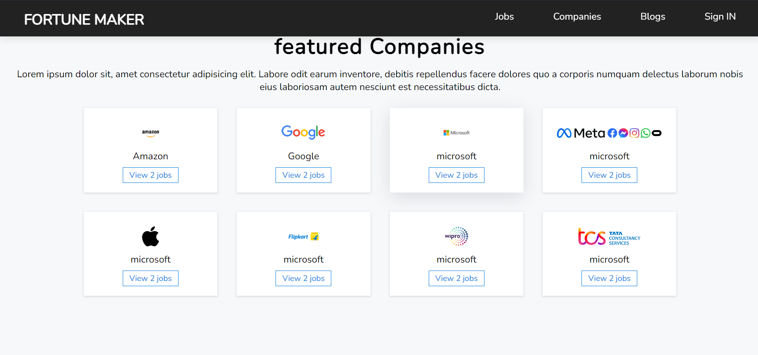

## CONCLUSION:

The main is to maintain the restaurant’s functions in an effective and accurate manner and also it is reducing the use of manual entries. The software helps food orders to maintain day to day records in system. It is keeping a proper record of the database.

# REFERENCES:

* N.B. Venkateswarlu and E.V. Prasad, C and data structures, S.Chand publishing,1st Edition,2010.
* Reema Thareja, Programming in C, Oxford University Press, 2nd Edition,2015.
* Stephen G.Kochan, Programming in C, Pearson Education, 3rd Edition, 2005.
* PradeepDey,ManasGhosh,Programmi ng in C, Oxford University Press, 2nd edition,2011.
* E Balagurusamy, Computer Programming,McGraw Hill Education, 1st Edition.